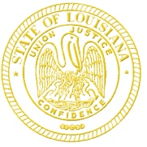 | State of Louisiana  Office of the Governor  DRUG POlicy
John Bel Edwards  Governor |  | Dr. Chaunda Mitchell  Director, Drug Policy & Executive Director, Diversity and Inclusion  Kristy Miller  Project Director
PUBLIC MEETING NOTICE

The Office of Drug Policy announces the following public meeting to which all persons are invited to attend.

Subject: Drug Policy Board

Meeting Date: Monday, November 18, 2019

Meeting Time: 10:00am – 12:00 pm

Meeting Location: State Capitol Building, 4th Floor Press Room

Contact: Kristy Miller, 225-235-3073 or Kristy.Miller@la.gov

************************************************
AGENDA

Call to Order

Welcome and Introductions

New Business
PSC recommendations to DPB

Other Business
Agency updates

Upcoming Meetings
- Drug Policy Board – January 16, 2020

Adjournment

